Sprint Report  
Sprint 3 Submission

Submission Date: 22 February 2021

Team A

Gregorson Mahon T00057640

Taylor Peck T00483746

Nicholas Piluso T00586492

Contents

List of tasks for the previous week 3

List of tasks for the coming week 4

Project Management Tool Screenshot 5

Updated Mock-ups or Other Relevant Documents 6

# List of tasks for the previous week

|  |  |
| --- | --- |
| Task Name | Responsible Team Member |
| **Attended Meeting:** Team discussed server options, selected AWS.  **Begin development on web site:** create preliminary web site interface components & MVC components | Taylor |
| **Attended Meeting:** Team discussed server options, selected AWS.  **Continue development of SQL Database:** Finish preliminary ER diagram, Used MySQL Workbench to create a database schema | Gregorson |
| **Attended Meeting:** Team discussed server options, selected AWS.  **Set up Server:** Set up AWS EC2 Ubutnu server with LAMP + MyPHPAdmin and Python  **Development of the Application Server:** figured out how to determine if the coordinates for a particular house are in an outage area defined as a set of polygon coordinates. | Nick |

# List of tasks for the coming week

|  |  |
| --- | --- |
| Task Name | Responsible Team Member |
| **Team Meeting for server connectivity:**   * Obtain/distribute server passwords * Set up PHPMyAdmin, PuTTY and WinSCP access | All Team Members |
| **Continue development on web site:**   * Upload exiting preliminary web site files to GitHub * Create functionality to create/signin a user * Integrate create/siginin functionality with the view/controller * Server side user validation | Taylor |
| **Finish initial development of SQL Database:**   * Upload database schema to server * Resolve any bugs/failures in the database schema that arise   **Switch to development of web site:**   * Onboard to the web development by reviewing exiting web site files * Begin working with Taylor to continue developing web interface components. | Gregorson |
| **Complete the Server Setup:**   * Resolve any connectivity bugs that come up during the server connectivity meeting.   **Continue development of the Application Server:**   * Develop ability to send emails, * Implement functions that create user messages, * Connect the app server code to the newly created database. | Nick |

# Project Management Tool Screenshot

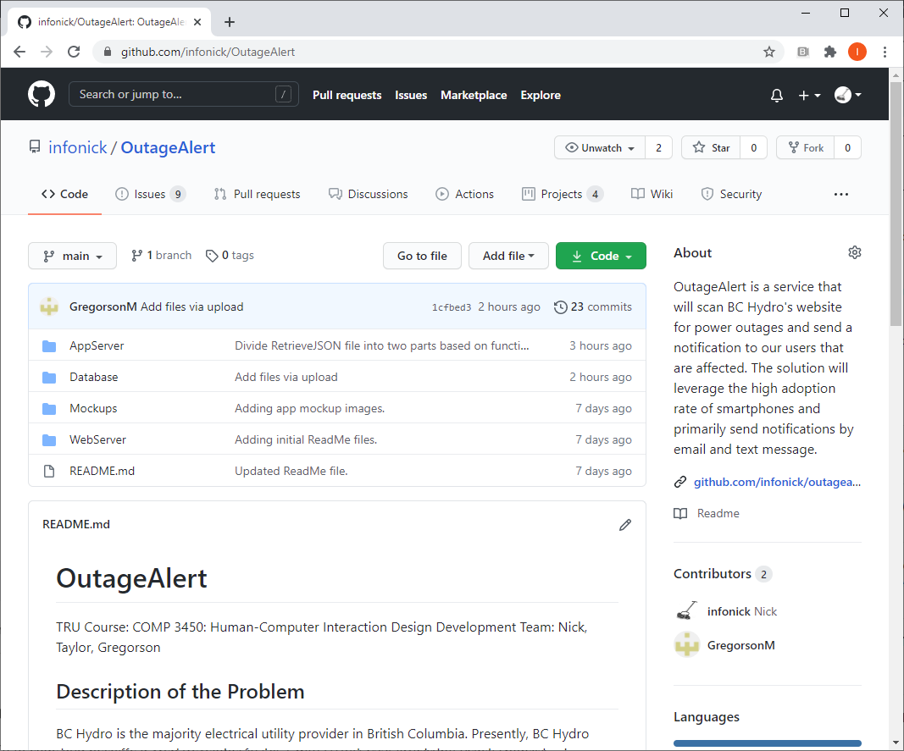

Interested readers may review the GitHub: <https://github.com/infonick/OutageAlert/>

# Updated Mock-ups or Other Relevant Documents

N/A for this sprint